**TECHNOLOGICAL INSTITUTE OF THE PHILIPPINES**

**QUEZON CITY**

**COLLEGE OF INFORMATION TECHNOLOGY EDUCATION (CITE)**

**ITE001- Computer Programming 1**

**NAME: Buenaventura, Aristotle C.**

**PROGRAM/SECTION: BSIT / IS11S1**

**ASSESSMENT TASK:**  **Activity 4.2. Functions**

1. **SOURCE CODE:** Write or paste the program code below

#include<iostream>

#include <string>

using namespace std;

void playgame() {

cout << "Play game called";

}

void loadgame() {

cout << "Load game called";

}

void playMultiplayer() {

cout << "Play multiplayer game called";

}

//funtion signature

double getIncome(string);

double computeTaxes(double);

void printTaxes(double);

int subtraction (int a, int b) {

int r;

r = a - b;

return r;

}

int divide (int a, int b=2) {

int r;

r = a / b;

return (r);

}

void odd (int x);

void even (int x);

void zero (int x);

// factorial calculator

long factorial (long a) {

if (a>1) {

return (a*factorial(a-1));

} else {

return 1;

}

}

int main() { // main function

cout << "\tTECHNOLOGICAL INSTITUTE OF THE PHILIPPINES QUEZON CITY" << endl;

cout << "\t\tFirst Semester S.Y. 2020-2021"<< endl;

cout << "\t\tITE001 Computer Programming 1\n"<< endl;

cout << "Name: " << "Aristotle" << "\t\tDate: " << "1/6/2021" << endl;

cout << "Program: " << "BSIT" << "\t\tSection: " << "IS11S1" << endl;

cout << "Activity 4.2. Functions\n"<< endl;

cout << endl;

// Example 1

int input;

cout << "1. Play game\n";

cout << "2. Load game\n";

cout << "3. Play multiplayer\n";

cout << "4. Exit\n";

cout << endl;

cout << "Selection: ";

cin >> input;

switch (input) {

case 1:

playgame();

break;

case 2:

loadgame();

break;

case 3:

playMultiplayer();

break;

case 4:

cout << "Thank you for playing!\n";

break;

default:

cout << "Error, bad input, quitting\n";

break;

}

cin.get();

cout << "\n\n-------------------------------------------------------------------------------------\n\n" << endl;

// Example 2

// Get the income

double income = getIncome("Please enter the employee's income: ");

// Compute taxes

double taxes = computeTaxes(income);

// Print employee taxes

printTaxes(taxes);

cout << "\n\n-------------------------------------------------------------------------------------\n\n" << endl;

// Example 3

int x = 5, y = 3, z;

z = subtraction (7,2);

cout << "output of the first function call: " << z << "\n";

cout << "output of the second function call: " << subtraction (7,2) << "\n";

cout << "output of the third function call: " << subtraction (x,y) << "\n";

z = 4 + subtraction (x,y);

cout << "output of the fourth function call: " << z << "\n";

cout << "\n\n-------------------------------------------------------------------------------------\n\n" << endl;

// Example 4

cout << divide (12) << "\n";

cout << divide (20,4) << "\n";

cout << "\n\n-------------------------------------------------------------------------------------\n\n" << endl;

// Example 6

long number;

cout << "Please enter the number you want to get the factorial: ";

cin >> number;

cout << number << "! = " << factorial (number);

cout << "\n\n-------------------------------------------------------------------------------------\n\n" << endl;

// Example 5

int i;

do {

cout << "Please, enter a number: (0 to exit) ";

cin >> i;

odd(i);

} while (i!=0);

cout << "\n\n-------------------------------------------------------------------------------------\n\n" << endl;

}

double computeTaxes(double income) {

if( income < 5000) {

return 0.0;

} else {

return 0.07*(income - 5000.0);

}

}

double getIncome(string prompt) {

cout << prompt;

double income;

cin >> income;

return income;

}

void printTaxes(double taxes) {

cout << "Taxes is $ " << taxes << endl;

}

void odd (int x) {

if ((x%2) != 0) {

cout << "It is odd. \n";

} else if ((x%2) == 0) {

even (x);

} else {

zero (x);

}

}

void even (int x) {

if (x==0) {

zero (x);

} else if ((x%2) == 0) {

cout << "It is even. \n";

} else {

odd (x);

}

}

void zero (int x) {

if (x==0) {

cout <<"You have entered zero. \n";

cout <<"Good bye!";

}

}

// End of program

1. 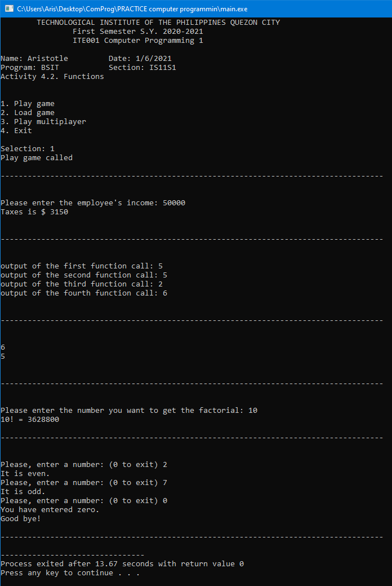**OUTPUT:**